Bandit Level 6
DG Interns Hub | Week 1 | OverTheWire Bandit Writeup

Objective
Find a file by size and other attributes.

Activity summary
Suggested learning command / approach: find inhere -type f -size 1033c ! -executable. Use only on the authorized OverTheWire training environment.

Key learning
Filtering files with find.

Evidence
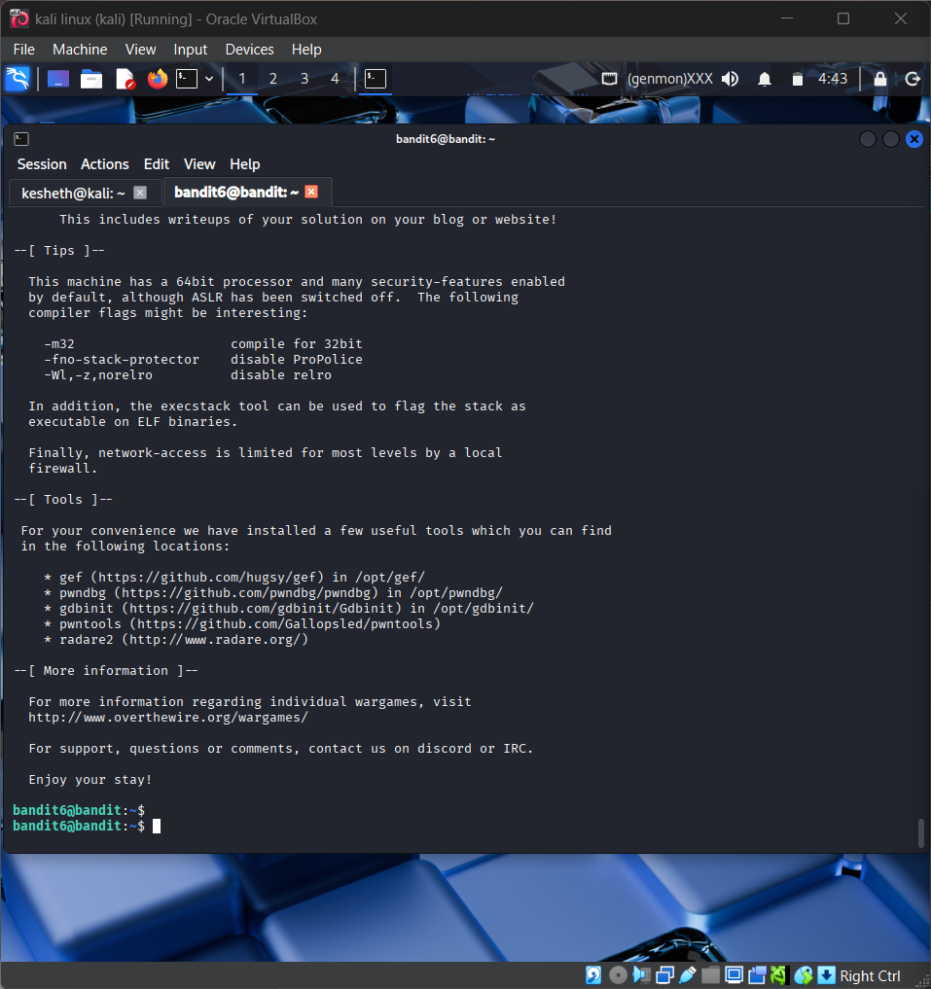
Screenshot: Bandit_Level_6.png
The screenshot is evidence of level activity/login; it may not show every solution step. No passwords are reproduced.

